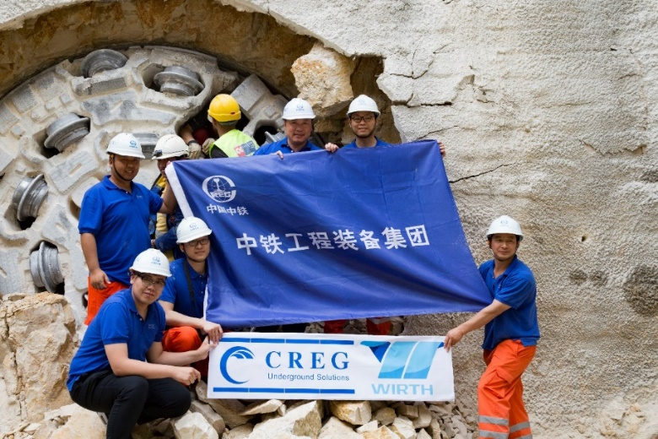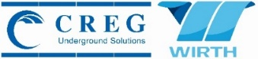On 5 May 2017, CREG’s 3.5m diameter gripper TBM LEA made its first breakthrough of Tunnel Drive 3 in the Greater Beirut Water Supply Project. A celebration was held in presence of representatives from CMC di Ravenna (the contractor), the local authorities, CREG and all project partners.

***CREG Gripper TBM First Breakthrough in Lebanon***

The Greater Beirut Water Supply Project including the construction of tunnels extending for approximately 24 kilometers and transfer lines for the potable water supply of Beirut is contracted by Italian CMC di Ravenna. This water supply project can be divided into two large parts: tunnels in the hilly area and underground pipelines in the urban area. The tunnels (called Drive 1, 2 3) will be completed by two gripper TBM. CMC signed a contract with CREG on the supply of two gripper type hard rock TBMs in June 2015. The two 3.5m diameter gripper TBMs are named “LEA” and “YASMINA” respectively. The TBM LEA is planned to bore Tunnel Drive 3 (4.13km) firstly and then shall be transferred to bore Tunnel Drive 1 (8.10km) while the TBM YASMINA is planned to bore Tunnel Drive 2 (10.37km).

The local geology mainly consists of limestone, dolomitic limestone and dolomite, behaving intact to moderately weathered, with UCS strength from 50 to 170 MPa. According to the geotechnical investigation, a lot tectonic faults and highly fractured rock will be encountered during mining. Gripper TBM shall go slowly and it required the use of supports like wire mesh and ring beams in order to avoid any risk. The maximum inclination of 4.97% for Tunnel Drive 3 alignment is designed in order to pass under existing valley. It is a big challenge for an open gripper TBM specially when dealing with de-watering works. Despite of those difficulties especially type of dangerous rock encountered, TBM LEA’s average overall rate since the launching of the TBM is 18m/day, whereas the maximum records on daily rate was noted 48.22 m/day and on April 2017 the monthly rate was noted 894.8 m/month and up to 98.63% machine availability.

The second set of TBM YASMINA is launched on 11 September 2016, YASMINA has successfully driven through the tunnel section on minimum radius curves of 300m in the initial stage, and it has driven over 4.5km.

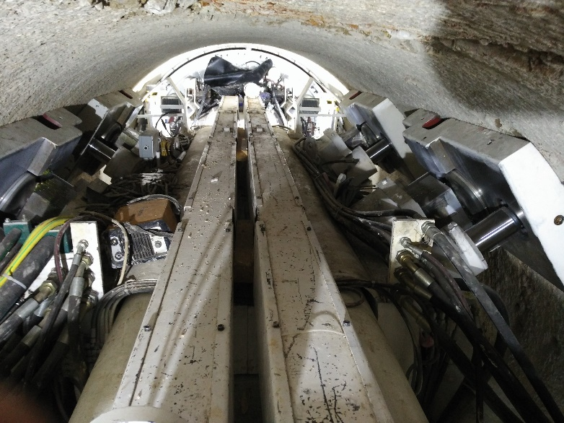

The performance of the TBMs have been highly commended at the breakthrough ceremony by Mr. Paolo Mauri, Area Manager of Middle East of CMC di Ravenna. “We reach a good record. We reached more than 48 meter for daily rate, which was more than expected as a result. So I think it's definitely a good machine and a good assistance from CREG. It's the CREG's assistance and CREG's engineers, which is a big added value. And this makes the results.”

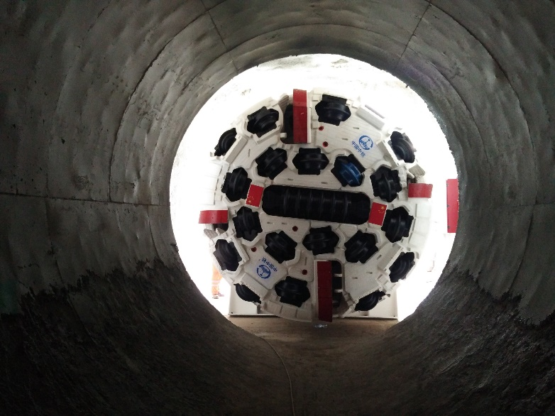

The Greater Beirut Water Supply project is scheduled to go into operation in 2019 to supply potable water for 1.6 million people in the region.

The TBM main characters are as follows:

* Boring diameter: 3500 mm
* Total length: 240 m
* Total drive power: 1200 kw
* Max. advance speed: 80 mm/min
* Thrust force: 8972 kN
* Breakout torque: 1800 kN∙m
* Rotation speed: 0-8.5-14.5 rpm
* Min. horizontal radius: 300 m